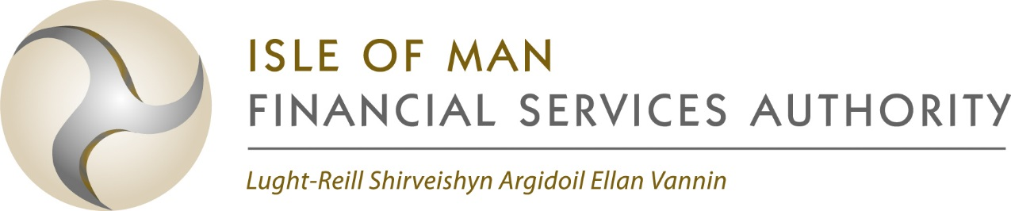

Collective Investment Schemes

Error Reporting form

ERROR REPORTING FORM
Name of Licenceholder:

Scheme Name:
Sub fund affected (if applicable):

Scheme Type:
(EIF/SF/QF/Full International/ Authorised/Regulated)

Fund Size (USD $ 000’s):

Date Error Identified:

Size of Error (actual and % of NAV):

Reason for Error:

Date of Valuation:
Impact on other valuation points:

Corrective Action Necessary:

Financial Impact on Scheme / licenceholder:

No. of shareholders affected:

Compensation paid (where applicable):

Submitted by: as Trustee / Licenceholder (delete as appropriate)

🔒 Data Protection Notice
The Authority is registered with the Information Commissioner as a data controller under Isle of Man data protection legislation. The Authority collects and processes personal data to carry out its functions under relevant legislation and may share personal data with other parties where there is a legal basis for doing so. Information on how the Authority collects and processes personal data can be found in the Privacy Policy on the Authority’s website:
https://www.iomfsa.im/terms-conditions/privacy-policy/
Please call +44 (0)1624 646000 if you have any queries.

Signature: Name in capitals:

Position: Date:

Note: See Rule 8.60 regarding notification of pricing errors. Form to be submitted within 15 business days of each quarter end (via the Authority’s online fund reporting portal where possible).

